ArtKick Image Database Editor

User Story

8/5/2013

The Image Database Editor allows an artkick content administrator to view the images in artkick database, edit the metadata associated with each image and delete images. It also allows the user to view artkick viewlists, edit the contents of viewlists, and associate viewlists with different categories. In a future version of the editor it will allow the user to import new images.

Within Artkick there are three objects related to images.

1. image records: this record has the metadata about each image, e.g. title, genre, artist, URL links to the actual image etc. These records are stored in a mongoDB so the attributes associated with each record can vary from record to record. At the present time they are all consistent across records but could change over time.

2. Viewlists are records which contain links to image records in a particular order. They allow the user to show a series of images on their connected TV. An Image can appear in multiple viewlists.

3. Categories are records which contain links to viewlists in no particular order. This is a way of categorizing viewlists. Viewlists can appear in multiple categories.

The operations of viewlists/categories/images are described in the documents “Zwamy data Structures” and “Zwamy Viewlists and Categories”

Figure 1 below is a sample UI

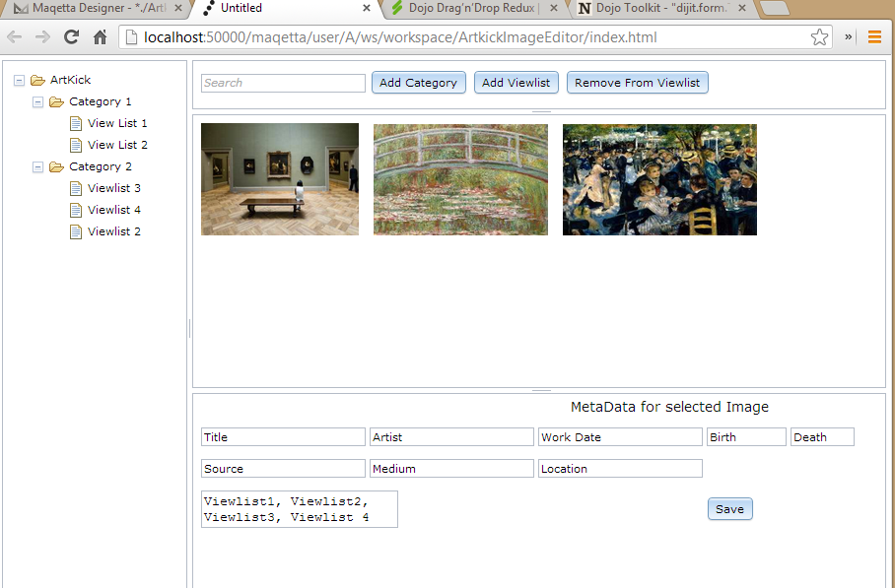

Operation of the Editor

On the left hand side of the screen is a tree control which allows the user to select the images to appear in the main window. If the user selects a viewlist, the images which are in the viewlist are displayed. If the user selects a category then all images from all viewlists in the category are displayed. If the user selects the top level node “Artkick” then all the images in the database are displayed. However this might be a problem since there will be thousands of images, so we may not allow this in the first version. The tree allows edits, so the user can right click on a Category or Viewlist and edit its name or delete it. A delete is not actually a delete, we simply mark the object as “not visible” in case the user needs to undo their mistake. There will be a command to empty the “trash” which will permanently delete the objects. ArtKick administrators can see all of the Categories and Viewlists and edit any of them. Individual users can see the Categories, Public Viewlists, and their own personal private Viewlists. Non administrators can only edit their own personal private Viewlists.

In the top panel there is a search button. When the user types something into this box and hits return, the images being displayed are filtered to the results of the search query. The search searches across all metadata fields. So the user could enter a title, artist, medium and what appears in the center panel would be those items which meet the search criteria, limited by what the user had selected in the tree. E.G. if Viewlist 3 was selected, the images in Viewlist 3 would be displayed in the main window. Searching only filters those images which are already displayed in the main window.

Add Category button pops up a dialog box into which the user enters the name of new Category. Category names must be unique across the entire system and can only be created by ArtKick administrators.

Add Viewlist button creates a new viewlist within the Category currently open in the tree. If the user is an ArtKick administrator the dialog asks the user for a name and whether the viewlist is public or private. If the user is not an administrator this choice is not visible. Public viewlist names must be unique across the system and can only be created by ArtKick administrators. Private Viewlist names must be unique for the individual user. A Private viewlist has the user’s ID associated with viewlist . Any individual user when seeing the viewlists in the tree, sees the public viewlists and their private viewlists. When displaying viewlists we will use an icon to differentiate between public and private viewlists.

Remove from viewlist button only appears when one or more images are selected in the center panel. Clicking this button then removes the selected images from viewlist and they disappear from the center panel.

Users can drag and drop images from the center panel onto viewlists in the tree. This allows a user to quickly add an image or images to a viewlist. They can multi select images to speed up the process.

Users can also drag and drop images in the center panel to reorder their appearance in the selected viewlist.

When the user selects a single image in the center panel, the meta data for the selected image is displayed in the bottom panel. If the user has more than one image selected the bottom panel is blank. Each of these fields is editable. The viewlist field shows the viewlists this image appears in. If they remove a viewlist then the viewlist is updated to reflect. The save button commits the changes the user made to the metadata. All of the metadata fields associated with the selected image are displayed, figure 1 only shows a selection of fields for demonstration purposes. Since different images can have different meta data fields, some of the fields will be blank. All of the fields are shown to allow users to add information which was not in the metadata originally.